Oppline: new amber alert
finds people where
normal gsm networks fail

Wirelessly whispering words about your whereabouts

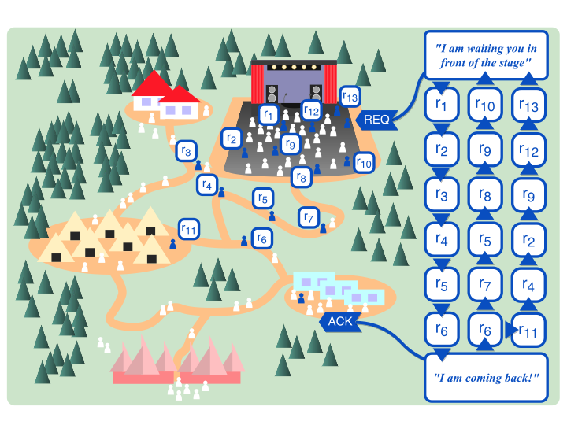
Text: MARC LAAN
Did you know that your smart phone has a secret life? It silently gossips about its existence to other handies, all by itself. Even without the use of wifi, bluetooth or cell phone networks. In fact our mobile phones are talking all of the time, even when lying seemingly dormant on the table.

This feature comes in as a smart tool for public safety, for instance when a friend or family member gets lost in a sports stadium, an outdoor festival, a pop concert or other crowded events. More often than not, the gsm networks in these places are down, because too many visitors are sharing pictures, sending Whats App messages or texting to friends.

Lost your little daughter in the crowd? Just tap on your newly downloaded Oppline app, and use the hidden messenger service of your smart phone to find your kin.

Interestingly, the more smart phones surround you in the crowd, the faster your message 'hops' from one phone to another in the public, finally reaching the device of your beloved one. The technical trick is, that phones in a crowd are capable of wireslessly whispering words to each other, thus delivering an encrypted message to the targeted cell phone of your contacts. It may take two or three hops, or maybe ten hops, but in a matter of seconds your message finds its way through the crowd, landing at the right persons smart phone.

Okun Türkes
Okan Türkes (1986), a computer engineer at the Technical University of Twente in the Netherlands, worked four years on his invention, which he named a 'friend finder'. Oppline is a short message service that uses the build in, but hardly known hidden hardware capabilities of our smart phones. “The communicating system for Oppline as such wasn't hard to design,” says Türkes. “It took some time however to write a fail tolerant software protocol. Now its works on iPhones, Android devices and Windows Phones.”
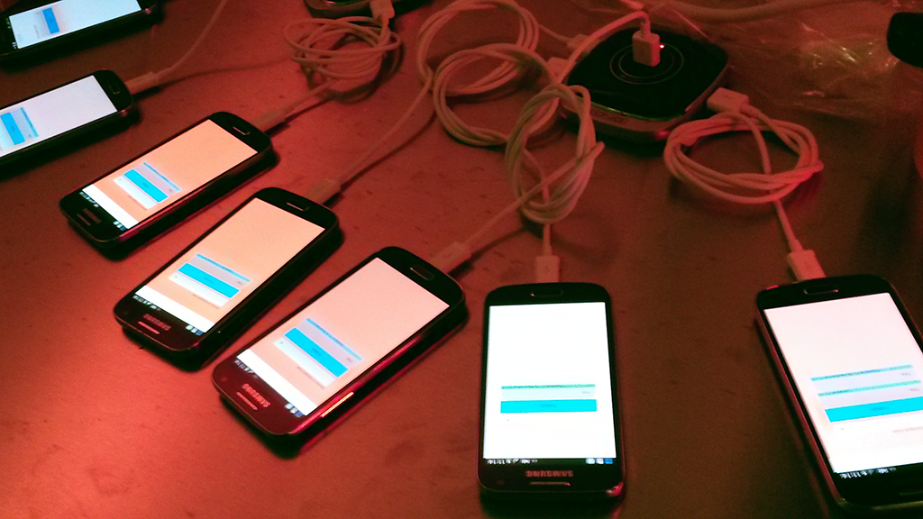
Every mobile device already has a wifi antenna, a standard wifi application layer and the capability to broadcast and receive so-called SSID beacons. This beacon is a short text field, normally used for wifi devices to recognize each other by name. Mobile devices, from phone to tablet and smart watch, are constantly scanning for those beacons, even if there is no wifi network active in the area.

What Türkes did, is smuggling a short encrypted text message of 32 bytes into the SSID field. “The phone broadcasts this line of text. A special software protocol instructs all other receiving devices to transmit this encoded message to each other, and finally to deliver it to the phone of your friend or family member.”

The Turkish born engineer tested his invention in the real world in a crowd with twenty phones, and concluded that his friend finder works even in dense networks. The Oppline app is battery friendly: it hardly consumes any energy.

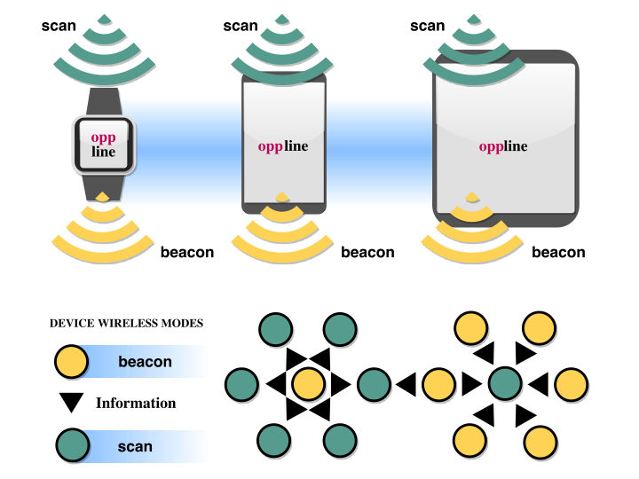Opplines data forwarding model
The SSID text line will be mathematically compressed, and contains data like the gps-location of the sender, a time stamp and an encrypted list of confidential recipients. “No other phone can read the private messages that are hopping over this ad hoc network.”
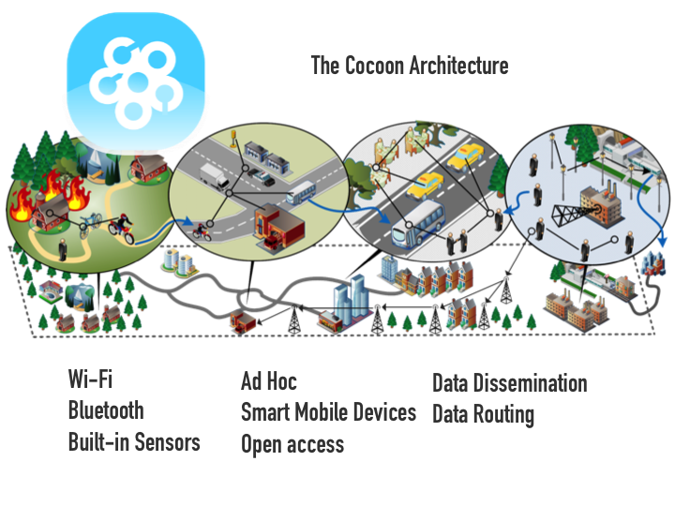
In august 2015 Türkes presented his friend finder at the Mobicom congress in Paris and was selected as one of the best apps in the conference. “I hope that this year Oppline will be in the app stores of Android, Apple and Windows. It will be open source software, financed by the Dutch national public/private ICT program Commit.”

Türkes expects that his invention will serve many more purposes. “One of our main goals was to develop an amber alert system, for locating missing children in a crowded environment. But we also did traffic tests in moving cars. The motion sensors in the smart phone successfully detected pot holes in the roads, and can even signal car collisions. In our office we use the system as a message board for colleagues. In the future it may be useful as a communication system in disaster areas, where wifi and gsm networks are destroyed after an explosion or an earthquake. Authorities can alert the public about emergencies. And of course you can use it to alarm your neighbors about burglars or a fire in your home.”

Some ethical questions are still to be solved, before Oppline is available for mass usage, warns Türkes. “The system must be privacy proof for citizens, but also criminal proof. The security of communications will be a great challenge. Users will only adopt this system if they are convinced that is both useful and safe.”

www.marclaan.nl

Marc Laan is freelance journalist for ICT, Finance, Health and Science.

-------------------------------
Read more about Oppline:

- http://ps.cs.utwente.nl/Blog/index.php?m=09&y=15

- Friend-to-Friend Short Message Service with Opportunistic Wi-Fi Beacons
(URL volgt)

- http://www.commit-nl.nl/sites/default/files/35. Using smart phones for emergency messaging.pdf

- Oppline is a plugin for the underlying communication protocol Cocoon (Community-oriented Context-aware Opportunistic Networking). OkanTürkes developed Cocoon and Oppline in collaboration with his Dutch PhD advisers Hans Scholten and Paul Havinga of Technical University Twente. He hopes to get his PhD degree in June 2016.

